Week 7
11. React-HOL
Explain React events
React events are interactions triggered by the user, such as clicks, typing, or form submissions. They are similar to native DOM events but follow React's own event system for better performance and cross-browser compatibility.

Explain about event handlers
Event handlers in React are functions that get called when a specific event occurs. They are used to define the behavior or logic that should run in response to user actions.

Define Synthetic event
A synthetic event is a cross-browser wrapper around the browser’s native event system. React uses synthetic events to provide a consistent API across all browsers.

Identify React event naming convention
In React, event names use camelCase (e.g., onClick, onChange), and the event handler is passed as a function inside curly braces. This is different from HTML, which uses lowercase event names.

Code :-
CurrencyConverter.js :-
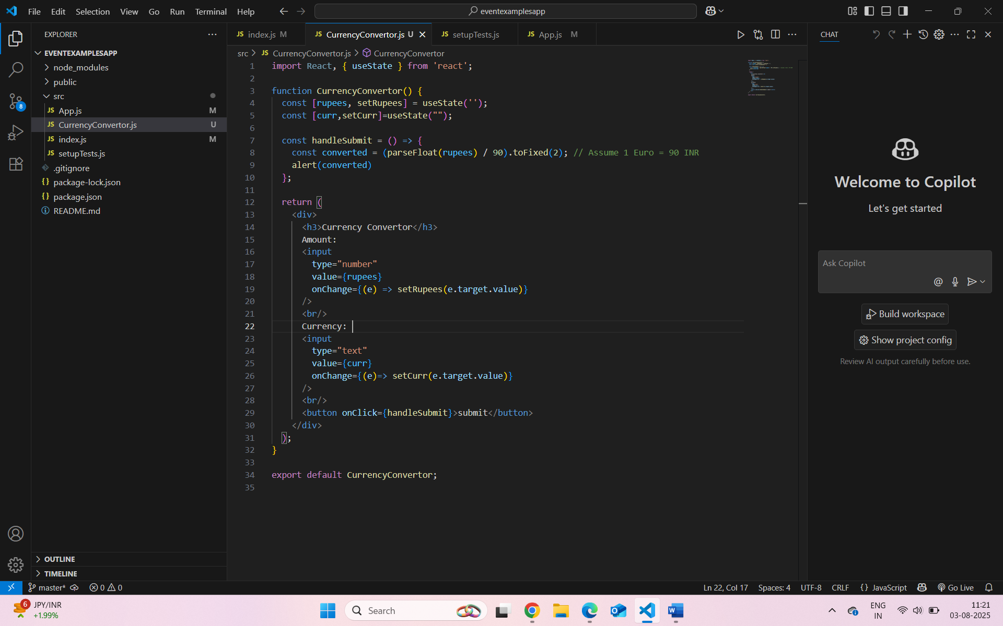
App.js :-
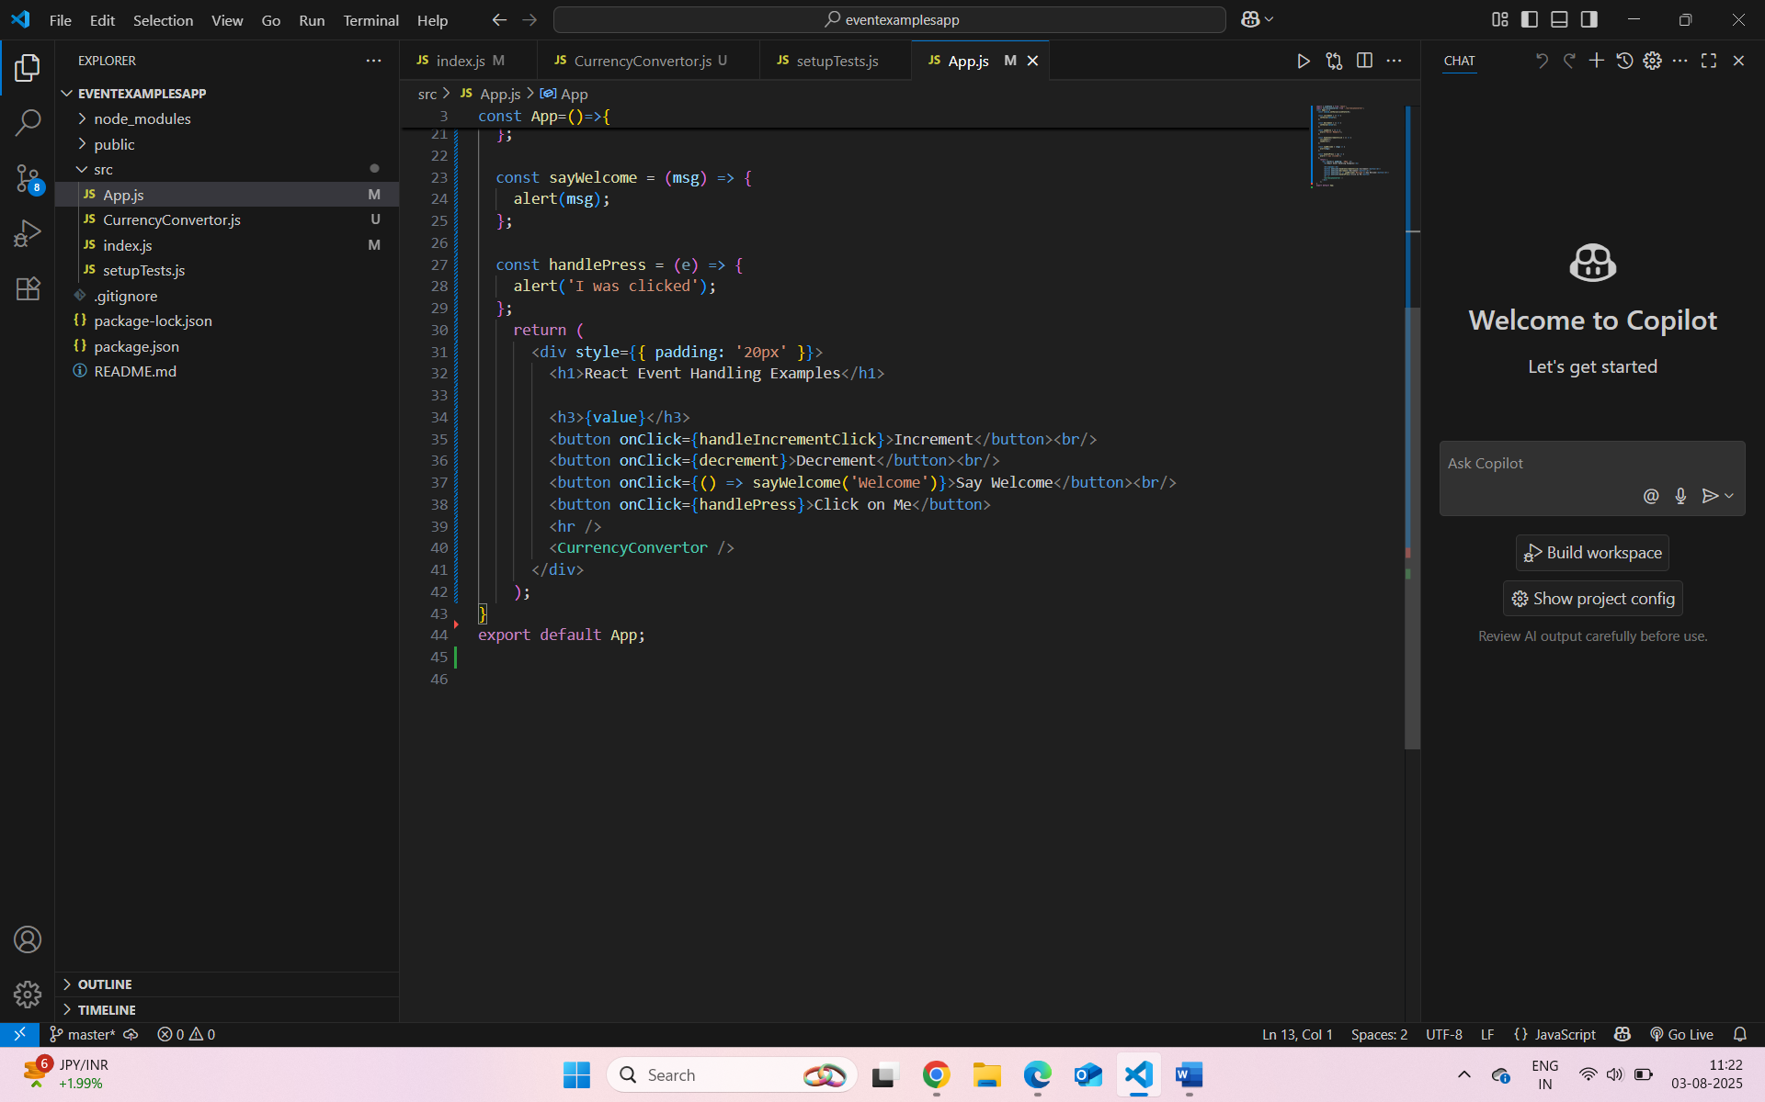

Index.js :-
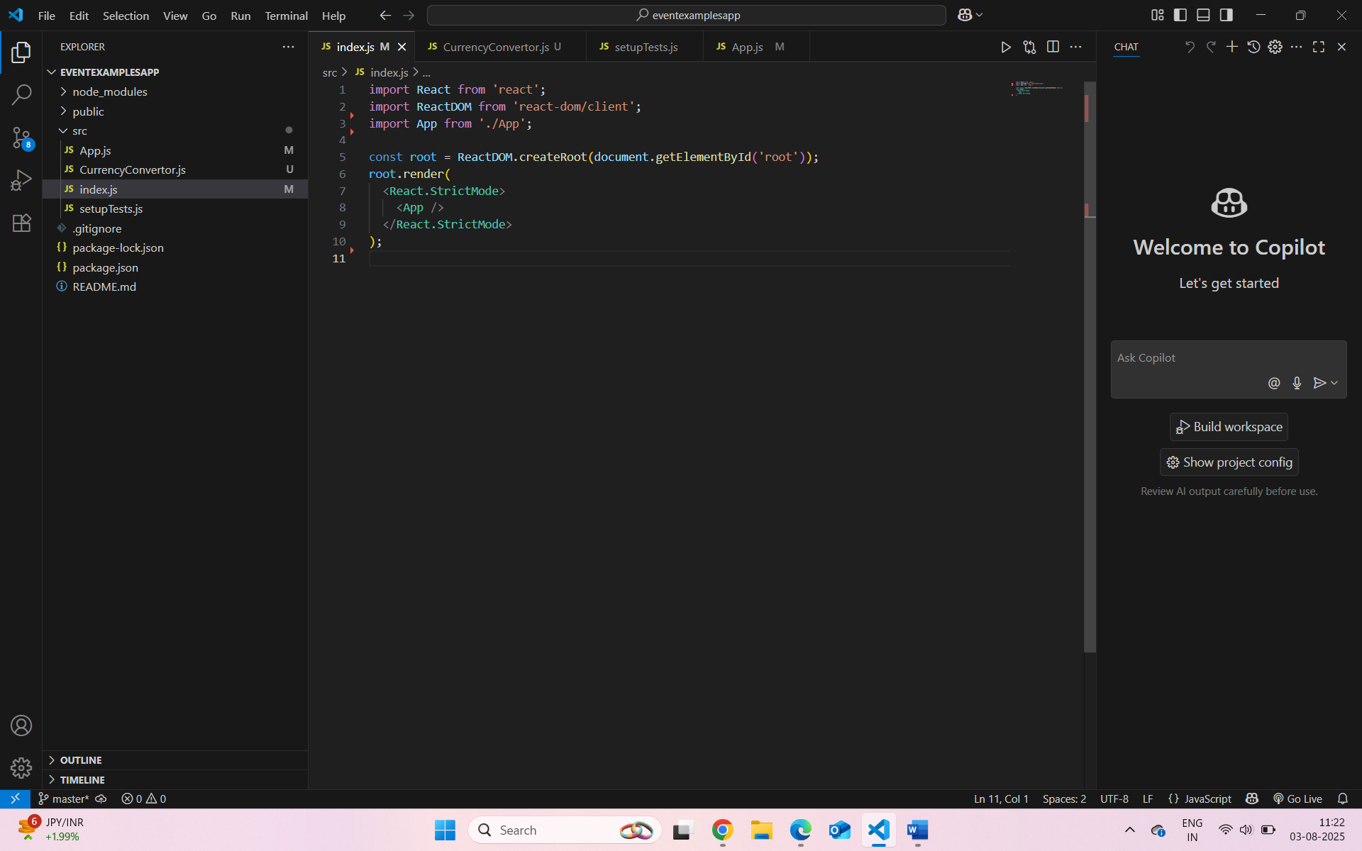
Localhost:3000 :-
